Project Design Phase-II
Technology Stack (Architecture & Stack)

Date | 01 October, 2026
Team ID | 6ab7ec71d083b0e2ee72a0a3
Project Name | Script-Controlled ACL – Restrict Record Access Based on Field Value
Maximum Marks | 4 Marks

1. Technical Architecture
User → ServiceNow Web UI → Authentication & Role Validation → ACL Engine → Script-Controlled Access Evaluation → Access Decision → Protected Records
The ACL evaluation checks:
User Role + Record Field Value → Access Allowed / Access Denied
It controls four operations:
- READ – View records
- WRITE – Update records
- CREATE – Create records
- DELETE – Delete records
It can apply when records are accessed through Forms, Lists and Service Portal.

Components & Technologies

S.No | Component | Description | Technology
1 | User Interface | Interface through which users access ServiceNow records and perform operations such as viewing, updating, creating and deleting records. | ServiceNow Web UI, Forms, Lists, Service Portal
2 | Application Logic-1 | Authenticates the user and identifies the user's roles and permissions before allowing access to records. | ServiceNow Authentication & Role Management
3 | Application Logic-2 | Evaluates ACL rules to determine whether the user can perform READ, WRITE, CREATE or DELETE operations. | ServiceNow Access Control Lists (ACLs)
4 | Application Logic-3 | Executes server-side scripts to compare the user's role with the specified record field value and make an access decision. | JavaScript / ServiceNow ACL Script
5 | Database | Stores the records and their field values that are protected by ACL rules. | ServiceNow Platform Database
6 | Cloud Database | Database is managed as part of the ServiceNow cloud platform; no separate cloud database is directly configured by the application. | ServiceNow Cloud Platform
7 | File Storage | No dedicated file-storage component is required for the ACL solution. | Not Applicable
8 | External API-1 | No external API is required for evaluating the ACL conditions. | Not Applicable
9 | External API-2 | No external API is required for user-role and record-field evaluation. | Not Applicable
10 | Machine Learning Model | Machine learning is not required because access decisions are based on predefined ACL scripts, roles and field values. | Not Applicable
11 | Infrastructure (Server / Cloud) | The application and ACL rules run within the ServiceNow cloud instance. | ServiceNow Cloud Platform

Application Characteristics
S.No | Characteristics | Description | Technology
1 | Open-Source Frameworks | No separate open-source framework is required. The solution uses ServiceNow's built-in ACL and scripting capabilities. | ServiceNow Platform
2 | Security Implementations | Security is enforced using user roles, ACL rules and server-side scripts. Access to READ, WRITE, CREATE and DELETE operations is granted or denied according to the user's role and record field value. | ServiceNow ACL, Roles, JavaScript
3 | Scalable Architecture | ACL rules are centrally managed within the ServiceNow platform and can be applied to multiple records, users and tables as the number of users and records increases. | ServiceNow Platform & ACL Engine
4 | Availability | The solution runs within the ServiceNow cloud environment, allowing users to access the application and security controls through the ServiceNow instance when the platform is available. | ServiceNow Cloud Platform
5 | Performance | ACL scripts are executed during access evaluation. Scripts should use simple role and field-value checks and avoid unnecessary database operations to reduce access-evaluation overhead. | Server-side JavaScript / ServiceNow ACL Engine
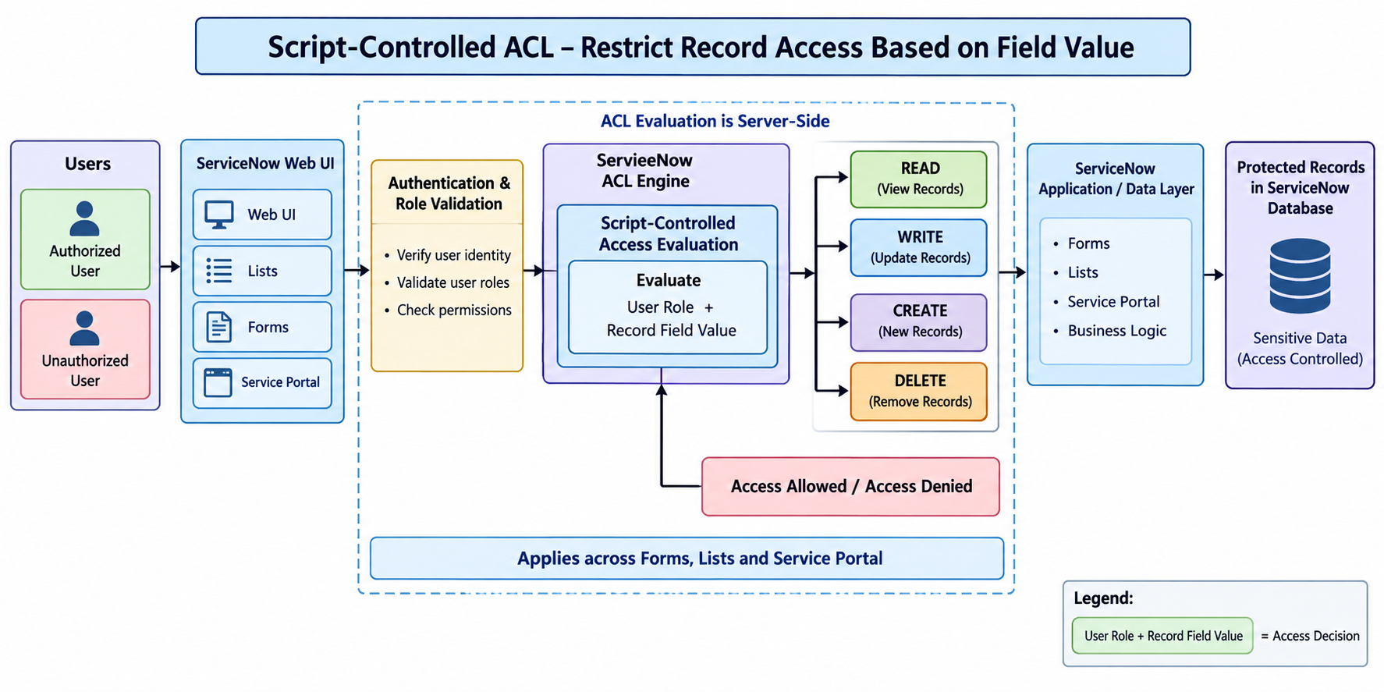

Step 1 – User Access
The user accesses a ServiceNow record through the Web UI, Form, List or Service Portal.

Step 2 – Authentication & Role Validation
ServiceNow identifies the user and checks the user's assigned roles and permissions.

Step 3 – ACL Evaluation
The ServiceNow ACL Engine evaluates the applicable ACL rule.

Step 4 – Script Evaluation
The ACL script checks the combination of:
User Role + Record Field Value
For example, the script may allow a particular role to access records only when a specified field contains an allowed value.

Step 5 – Access Decision
The ACL produces one of two outcomes:
Access Allowed ✅
or
Access Denied ❌

